Absolute Synonyms

🔹 What is Absolute Synonyms
# Source: Chatgpt (GPT-4-turbo) at [7/30/2025]
Absolute synonyms (also called true synonyms) are words that can be interchanged in all contexts without changing the meaning, tone, or usage of a sentence.

🧠 Definition:
# Source: Chatgpt (GPT-4-turbo) at [7/30/2025]
Absolute synonyms are pairs (or sets) of words with exactly the same meaning, grammatical function, and contextual use—with no difference in connotation, formality, or usage.

📌 Key Features:
# Source: Chatgpt (GPT-4-turbo) at [7/30/2025]
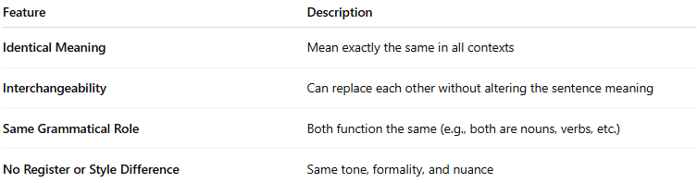
Feature | Description
Identical Meaning | Mean exactly the same in all contexts
Interchangeability | Can replace each other without altering the sentence meaning
Same Grammatical Role | Both function the same (e.g., both are nouns, verbs, etc.)
No Register or Style Difference | Same tone, formality, and nuance

📚 Examples of Absolute Synonyms:
# Source: Chatgpt (GPT-4-turbo) at [7/30/2025]
(Note: These are rare and sometimes debated)
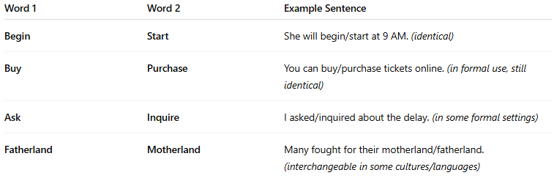
Word 1 | Word 2 | Example Sentence
Begin | Start | She will begin/start at 9 AM. (identical)
Buy | Purchase | You can buy/purchase tickets online. (in formal use, still identical)
Ask | Inquire | I asked/inquired about the delay. (in some formal settings)
Fatherland | Motherland | Many fought for their motherland/fatherland. (interchangeable in some cultures/languages)

⚠️ Note:
# Source: Chatgpt (GPT-4-turbo) at [7/30/2025]
True absolute synonyms are rare in natural language. Most synonyms have slight differences in:
- Tone (e.g., casual vs formal)
- Usage (regional or idiomatic)
- Collocation (what words they usually go with)

